Music & MIDI in Magic Cap
by Brenda Holloway
Sony New Technologies
brendah@mbay.net

001-58-8424
215 Cosky Drive
Marina, CA 93933-2311

Wanting to give Magic Cap users the ability to send songs along with their e-mail, but not wanting to use up the valuable memory space such songs would use (to say nothing of the time it would take to send a song of any length through a modem), General Magic had the notion to include a complete music synthesizer in Magic Cap - and to make things easier for song writers, made it compatible with the MIDI standard for controlling such synthesizers.
In so doing, the Magic Cap programmers opened the doors for anyone to add songs of their own to their communicatorsÉ if they only had some way of getting the songs from their heads - or their instruments, or even their computers - into the devices.
In this article, IÕll describe Magic CapÕs support for music and sound, especially in regards to its MIDI synthesizer. Along the way, weÕll look at MIDI itself, getting songs into the communicator (and out again), and IÕll describe the MIDI sequencer - ÔMinstrelÕ - IÕve written - a program for composing songs on the communicator itself.
What is ÔMIDIÕ?
The Musical Instrument Digital Interface, or ÔMIDIÕ, is a grand specification for linking together all sorts of different kinds of electronic instruments. It both specifies the electrical interface for the wires that connect the instruments, as well as the messages sent along them. Since the introduction of MIDI at the 1983 NAMM (North American Music Manufacturers) show, it has become the de facto standard for connecting electronic instruments. First used mainly to connect synthesizers (starting with YamahaÕs venerable DX-7), it now can be found on everything from guitars and drums to special platforms where dance and movement are turned into musical notes.
The MIDI standard is so widespread that connecting my digital piano bought ten years ago with my synthesizer was a simple as plugging a cable from one to another; and both worked with my long-obsolete Atari 520ST computer, one of the few that came with MIDI ports built in.
MIDI Notes
There are a few concepts about MIDI and music in general that I need to cover. There are 128 different notes that MIDI can specify, numbered from 0 through 127. Think of it as a piano keyboard with an extra forty keys. These notes are arranged in octaves, which are collections of twelve half steps, the distance from one note to the next. These correspond to the twelve notes of an evenly tempered scale (see figure 1). By the diagram below, you can see that the ÔCÕ and the ÔDÕ are separated by two half-steps (also know as a whole step), while ÔEÕ and ÔFÕ are separated by just one. This is the standard ÔwesternÕ scale, chosen because itÕs relatively simple to form harmonies and pleasing chords with it in a variety of keys.
There are ten complete objects, numbered from -1 to 8, plus some extra notes for a partial eleventh octave. MIDI notes are denoted by their letter and octave number; Middle ÔCÕ, the first note of the octave closest to the center of a standard 88-key piano keyboard, is defined as note number 60, or C4. This is more of a convenience for the musician, though, since MIDI itself only cares about note numbers, not which octave theyÕre in.
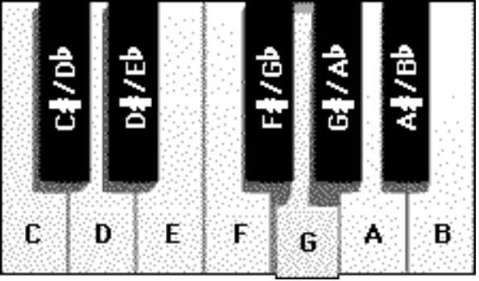
[** Figure 1 Ð an octave of notes **]
The Hardware Standard
Though no current Magic Cap communicator has the necessary hardware to connect into a MIDI network, a few words are in order. Maybe some ambitious soul out there might want to build an interfaceÉ
A device on a MIDI network can be a sender, which transmits MIDI messages, a receiver, which receives MIDI messages transmitted by another device, a listener, which passes along MIDI events, or any combination of these. A simple MIDI setup might have a master keyboard send MIDI messages to a rack-mounted synthesizer, which is connected to an amplifier and speakers. In this case, the keyboard would have a MIDI Out port, and the synthesizer would have a MIDI In port (see figure 2).
You might add a sequencer in, that records the MIDI events but doesnÕt change them. It would have two ports; one for MIDI In, and another for MIDI Thru. A sequencer is a special machine (or more often now, a bit of software) that records groups of MIDI events, or sequences, for storage and playback. Modern sequencers can edit the MIDI stream as well, rearrange them into tracks, and exchange data with our sequencers.
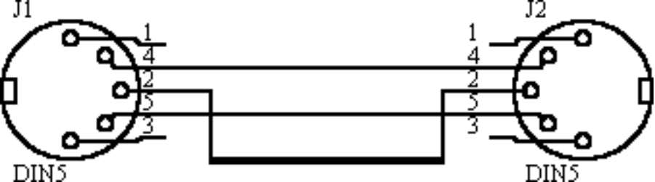
[** Figure 2 Ð MIDI ports **]
MIDI Events
MIDI events are usually generated by someone, somewhere, playing an instrument, although in these times, with computers everywhere, an event might just as well have been created automatically by a composer program. Nonetheless, an event is meant to stand for some user action.
The most common events are note on and note off. The Note On event is sent by pressing a key on a keyboard, plucking a string on a guitar, whacking a drum, or some similar action. It sends along the specific note hit (out of the 128 possible MIDI notes), how hard it was hit (called velocity, and usually used to determine how loud the note is, as well as how sharp the attack was), and what channel the event was sent on. A channel (there are sixteen possible channels) is an easy way of letting instruments know which events concern them; you might program a special effects device to respond only to events on, say, channel 3, and ignore notes coming through on any other channel.
Note Off is sent when the musician releases the key, silences the string, and so on. It, too, includes the channel and velocity.
A third event, program change, determines which patch should be associated with a given channel. Modern synthesizers can play hundreds of sounds, or patches. The Program Change event selects which one to use.
In the sample sequencer IÕve written for this article, we use only these three MIDI events. There are several more that deal with the nuances of sound production (with such names as polyphonic aftertouch and the catch-all system exclusive), but theyÕre beyond the scope of this article.
General MIDI
One last item before I start talking about music in Magic Cap. Although the most basic MIDI events have been standardized, various new standards have arisen over the last decade or so. The most popular of these is General MIDI, a standard collection of patch numbers defined by Roland in its popular SoundCanvas synthesizer. For instance, patch 1 is defined to always be your basic piano patch; in devices that support General MIDI, sending a Program Change event for patch 1 will always enable a piano.
There are 128 standard patches, running the gamut from accordion to xylophone and special sounds such as applause, rain, gun shots and jets. Percussion is always controlled by channel 10; and there are other details of General MIDI.
Magic Cap does not support General MIDI. The limited memory in devices precludes storing that many separate instruments. The seventeen instruments included in Magic Cap strain the available space already. What MIDI support there exists in the operating system is there only to accommodate the built-in tunes; Magic Cap was never intended to provide serious support for music applications. Still, they could have done some basic patch number translationsÉ

[** Figure 3 Ð The General MIDI logo **]
Magic Cap and MIDI
Since the current crop of Magic Cap-using communicators do not support the special hardware necessary to connect into a MIDI network, itÕs somewhat of a mistake to say that Magic Cap supports MIDI. Its support for MIDI is limited to reading the MIDI file format, a standard for saving MIDI events along with the times those events occurred. The file format consists of a header, which describes, in general, the rest of the file, followed by one or more tracks.
The definition of a track depends on the type of file format defined. A MIDI file of format Ô0Õ has just one track, with all the events for all the channels jumbled willy-nilly together. This is the format Minstrel writes, and is the lowest common denominator MIDI file format. Every program that works with MIDI files should be able to read, and probably write, format 0 files.
A format Ô1Õ file defines a single song with multiple tracks. This is the typical output of most composition software. The tracks can be any combination of events and instruments, just as if they were multiple Ôformat 0Õ tracks. Convention usually assigns the first track (called track 0) to carry the name of the song, and all the timing, tempo changes, and other non-instrumental events. The succeeding tracks usually are assigned to a single instrument, though all percussion is often confined to a single track. All the songs in Magic Cap are stored as format Ô1Õ files.
Format Ô2Õ files store multiple single-track songs, and are usually used for storing related sequences, such as drum loops. As far as I know, Magic Cap does not support format Ô2Õ files.
Built into Magic Cap is a small synthesizer which reads format 0 and 1 files directly. To have your communicator play a song, all you have to do is write the correct sort of file and ask Magic Cap to play it.
Instruments
There are seventeen ÔinstrumentsÕ in Magic Cap. I quote that, because the operating system does not actually synthesize sounds the way many synthesizers do, by building a sound from various sorts of oscillator-generated wave forms. Instead, for each instrument, a single note of that instrument was recorded, and that note is shifted in frequency to simulate all other notes. YouÕd imagine that notes fairly close to the sampled note would sound best, and youÕd be right. The notes are only useful at less than an octave (eight notes to an octave, not including flats and sharps) from the sampled note. One instrument, the piano, has three samples (spread across three instruments) to allow for the sort of range the sound requires.
Instrument sounds have three components; attack, which is the first sounding of the note; sustain, which is the sound the instrument makes as the note is held; and decay, the sound of the instrument when the note is no longer sounded. Using the piano as an example, when someone presses a key, the sound quickly rises, then slowly falls off while the key is held, and is then quickly silenced when the key is lifted. (The piano is a difficult instrument to sample; a single key press can sound as many as three strings, not to mention the sympathetic vibrations of other strings, the harmonics as the sound of the strings interfere with each other, and the resonance of the cabinet).
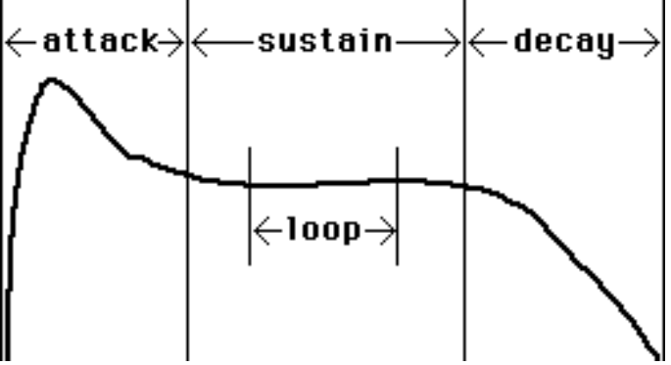
[** Figure 4 Ð The anatomy of a sound **]
Shifting the note back and forth through the entire scale solves to some extent the problem of recording a sample for each note, but it doesnÕt help with the noteÕs sustain. A note sounded and then immediately released on a piano sounds very different from one held for two seconds, or a minute. Since thereÕs no room to spare for keeping a good variety of notes with various sustains around, Magic Cap simulates sustain with looping.
In looping, a representative bit of the sustain is recorded. As long as the note is held, the loop is repeated. ItÕs a difficult problem to make sure the note sounds enough like the beginning of the loop at the end of the loop so that the listener doesnÕt hear a click, or detect an unusual regularity in the sound. One way of solving this problem is to keep the loop sample very short, so the sound doesnÕt have much time to decay or change, which is the solution used in Magic Cap.
Given all these limitations, many of the sounds are very rich and full, especially the lowest of the three piano samples. The thought of any sort of synthesizer at all in a device this small not solely devoted to music is incredible!
The seventeen instrument samples are: Piano (high, medium and low), Strings, Clarinet, Trumpet, Piccolo, Acoustic Guitar, Electric Guitar, Fretless Bass, Crash Cymbals, Ride Cymbals, Kick Drum, Snare Drum, Jingle Bells, Applause, and Whistles.
Getting MIDI Files into Magic Cap
The easiest way of playing a MIDI file under Magic Cap is to write it using some other software and paste it into Magic Cap using the simulator. This makes a sound coupon that holds the song, and this can be dropped onto most any viewable object. Of course, given all the limitations of the synthesizer, you must be very sure that the instruments used in the song match up with the Magic Cap instruments. General MIDI defines piano as instrument 1, and so does Magic Cap, so piano-only songs should transfer well (though they may sound tinny at the high end and distorted at the low). Usually, though, songs need a certain amount of preparation using composition software, and thatÕs getting way out of the scope of this article.
If you can receive uuencoded files via electronic mail, Greg SatzÕs UUDecode package makes MIDI songs out of MIDI files sent to you.
Getting MIDI Files out of Magic Cap
The quick answer is, you canÕt get MIDI files back out of Magic Cap. Remember, the communicator is not a synthesizer; it doesnÕt connect musically to the outside world. Given that, if you have your sound on the simulator, you could dump it to a file, then write a small program to translate the dumped information back to its binary form. The result would be a MIDI file with the instruments numbered by Magic CapÕs scheme. A little bit of work in some composition software should fix that up. Generally, though, once a MIDI file gets into the communicator, itÕs there for keeps.
The MIDISong and MIDIData Classes
Magic Cap supports two MIDI classes. MIDIData contains the MIDI file itself, while MIDISong determines the specifics of how Magic Cap plays the MIDI file.
MIDISong
HereÕs an abbreviated listing of the MIDISong class:

Define Class MIDISong;
inherits from Object;
inherits interface from Playable;
inherits from HasDigest;
collects members;

field instruments: ObjectList;
field tempoFactor: Fixed;
field duration: Unsigned;
field flags: UnsignedShort;
field songTempo: UnsignedShort;
field songPitchShift: UnsignedShort;
field defaultPlaybackRate: UnsignedShort;
field defaultInterpolationMode: UnsignedShort;
field compression: UnsignedShort;
field position: Unsigned;
field midiData: MIDIData;
End Class;

The MIDISong class inherits the standard media interfaces from class Playable - methods to play, stop, pause, and resume (after pausing) the song. Notice that it can’t inherit directly from Playable, since Playable is defined as inheriting from Object, and is not a mixin class.
There are three sorts of inheritance. In the first, and by far the most common, a subclass inherits both the interface (the operations and attributes of a class) and the implementation (the fields of a class) from its superclass. But if your subclass is so different from its superclass that it would have to override every operation and attribute, it can choose to inherit just the interface alone and write all the methods anew.
If, however, you would like to preserve the data structures used in your superclass but don’t need any of the methods, you can just inherit the implementation.
Whether inheriting the whole superclass or just its interface, the Implements method returns true when asked if the subclass implements the superclass, but false if it just implements the implementation.
The next line, inherits from HasDigest, allows objects to be located based on their data by calculating a 32 bit checksum (CRC) from the objectÕs extra data and storing that in a digest. Given an objectÕs data, it is then possible to construct a new CRC from that and find the original object. If I were to send someone an object that inherits from HasDigest, the receiving device could check to see if it already had the object by looking through a local digest. If there’s a match, one of the objects could be discarded, saving memory. If I had a piece of stationery that played a tune when read, I could send someone letter after letter with the tune on it, but your communicator would store the song only once and have every letter refer to that single copy.
The collects members statement is a hack ObjectMaker uses to keep track of the instances of this class and its subclasses; itÕs not useful for non-operating system classes. (Thanks, Dean).
MIDISongÕs Fields
Most of the fields in a MIDISong can be zeroed without any really bad side effects.
instruments holds a list of the various instrument note samples that are used to associate an instrument number in a MIDI file with the actual sound. Leaving this as nilObject uses the default system instruments; someone ambitious could map the 128 General MIDI instrument numbers to the seventeen built-in instruments and simplify song imports.
tempoFactor is a fixed point number that determines how fast the song plays as a ratio to the recorded rate. A value of 1.0 here (0x00010000 in hexadecimal) plays the song at the recorded rate; 2.0 plays it twice as fast, 0.5 plays it half as fast. This field should never be 0.
duration is the length of the song in milliseconds when played at a tempoFactor of 1.0. This field does not need to be filled in; Magic Cap will calculate it if you donÕt. However, itÕs been my experience that Magic Cap calculates it wrong. ItÕs best to just fill this in, if you possibly can.
The flags field sets up some various global options which specify how all instruments are sounded. kTerminateDecay (bit 15), if set, stops the sound after the first time through the looping part of the sound if there is another instrument ready to play. This is probably used to implement monophonic songs (one note at a time). Bit 14, kDisableClickRemoval, disables the routine in the Magic Cap synthesizer that balances the sound at the beginning and ending of a loop so that thereÕs no audible click. This does make the synthesizer work faster, at the expense of the sound. Bit 13, kEnablePitchRandomness, allows individual instruments to add a little random pitch variation to simulate the sound of a naturally played instrument. The last flag, kMidiSongNotSharedBit, bit 12, turns off the ÔsharedÕ property of the song. When a song is shared, destroying an object which has a reference to this song does not destroy the song unless there are no other references to it.
The songTempo field is zero to play the song at the default tempo, which is 16667. This should probably always be zero; you can change the playback speed of the song by using tempoFactor. songTempo is not related to the MIDI tempo value (more on that later).
songPitchShift shifts the entire song up or down the given number of notes (see above for a definition of what a note is, in MIDI terms).
The defaultPlaybackRate field determines the quality of the sound generated. The default is 44.1kHz, the best quality, but it can be set to 1 (22.05 KHz), 2 (11.025 KHz), or 3 (8 KHz).
Interpolation is a weighted average of two samples at different notes to make a pitch-shifted sample of a third note - sort of like ÔmorphingÕ one sound into another. The defaultInterpolationMode field defines how this is done. The default, 0, doesnÕt do it at all (since each built-in instrument has only one sample, thereÕs nothing to average). The other values (1 through 3) choose increasingly better, but slower, algorithms.
The compression field determines the compression method for the MIDI song; they are usually uncompressed, and this field should be zero.
The position field determines the current position in the song, and should never be set directly. The PlaybackPosition attribute takes care of this.
Lastly, the midiData field points to a MIDIData object, the object which contains the actual format 0 or 1 MIDI file.

MIDISongÕs Methods
MIDISong defines four operations which at first look would allow someone to make simple songs a note at a time just by making easy calls. Someone might write a simple piano simulator which called AddNote to add a note to the end of a given track as its played. Or perhaps a slightly more savvy package that recorded the initial pressing and the lifting of a key with a combination of AddNoteOn and AddNoteOff calls. ThereÕs even a kind of backspacing possible with DeleteNote.
Unfortunately, none of these methods do anything in the current version of the software. As General Magic came every nearer to shipping the first version of Magic Cap, they assigned priorities to various operating system features. And those parts of the MIDI implementation not needed for playing the built-in songs were stubbed out.
Why not create our own MIDISong class and define these unimplemented methods? Largely because the methods as they are defined do not take enough information (such as the times of the various events) to be incredibly useful, and secondly because it would certainly be nice to play songs we might compose with Magic Cap without having the composing package present. Only instances of native Magic Cap objects may be easily sent elsewhere.
In the end, I do, in fact, subclass MIDISong for my own ends, and define a variant of AddNote for my own use. All is not lost, however; there are methods I can use to devolve the EventSong (my subclass) to a MIDISong if it gets sent to a Minstrel-less communicator.

Minstrel
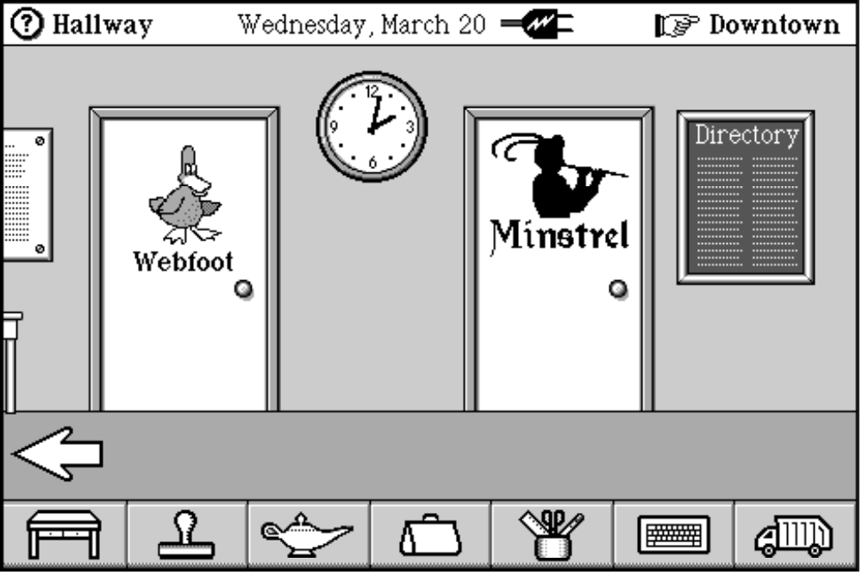
[** Figure 5 Ð ThereÕs a minstrel in the gallery! Must be rats nearby **]
Once, long ago, I had this crazy thought. ÒGee,Ó thought I, Òhow hard can it be to just build a little keyboard I can play tunes on? After all, MIDI is built-in!Ó.
Four months later, here it isÉ The original project kept getting more ambitious; I was going to do a full-blown bit of composition software so I could use the communicator as accompaniment when I practiced flute (good pianists are so hard to find!). So now its back to its basic form. But it writes and reads MIDI files, and that was the fun part, anyway.
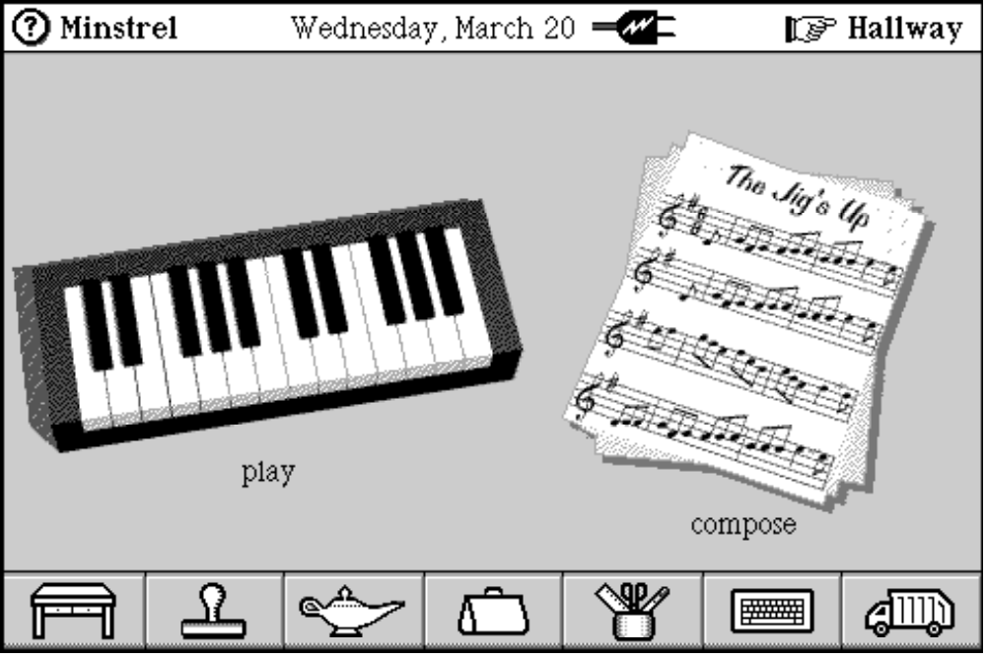
[** Figure 6 Ð Minstrel Menu Scene **]
The main scene (see figure 6) shows the two basic functions of Minstrel; the keyboard leads to the free-form playing scene, while the sheets of music lead to the composition scene.
The Keyboard Scene
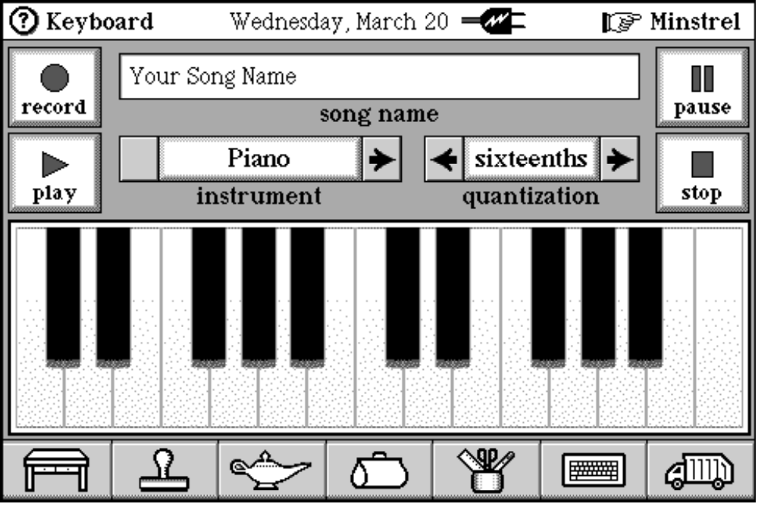
[** Figure 7 Ð the Keyboard Scene **]
The Keyboard Scene (figure 7) was the original root of Minstrel, the demo IÕd written that showed that MIDI was possible, just not all that easy. I rendered a keyboard using the Persistence of Vision freeware 3D ray tracer (part of the original rendering is shown in figure 1; note the shadows of the black keys and the different appearance of the ÔGÕ key, which is being pressed), animated it so that pressing the key looked like a key was being pressed, and then tried to figure out how to make it play a sound.
The original idea was that the sound would start when someone pressed a key, and then stop when they stopped pressing it. I used Bowser Pro, the Magic Cap class browser, to look through the various classes that implement Playable and found the Sound class.
The Sound class included the following methods:

operation PlayNote(pitch: UnsignedShort; duration: Unsigned);
operation QueueNote(pitch: UnsignedShort; duration: Unsigned);

Both seemed promising. The pitch is the MIDI note number, and the duration was the duration to hold the note, in milliseconds. I tried both of them, and they both worked pretty much the same. But I didnÕt know how long the note would play, since that was entirely up to the user. So I tried choosing a fairly long duration, thinking I could just stop the note at the right time.
I tried Stop, a method Sound inherits from Playable. It did nothing. I tried NoteOff, another method of Sound and the companion to NoteOn. Nothing. I tried playing the note with NoteOn instead, but that didnÕt work, either (actually, NoteOn and PlayNote are identical).
I noticed by tracing through the code that nearly all Sound methods called methods of the Speaker class to do their work. So I looked at that class, and saw this method:

intrinsic KillSounds; // stops all sound and unlocks everything

This seemed like it might do the trick, butÉ nothing. The Speaker class also defined two additional methods that I thought I could use:

operation PlayInstrumentNote(sound: Object; pitch: UnsignedShort; duration: Unsigned; loopContinueProc: Pointer; completionProc: Pointer);
operation EndInstrument(sound: Object);

PlayInstrumentNote actually included both a call-back function for looping, and another to call when the note was done. The loopContinueProc turned out to be a routine which was passed a parameter block of unknown origin, and returned true if it should continue. Needless to say, EndInstrument did not stop a note started with PlayInstrumentNote, so I pinned my hopes on the loopContinueProc. Since I couldnÕt pass it any parameters from my end of the world, I hacked a solution which modified the code of the routine itself before each call to let it know whether the key had been lifted yet.
And, surprisingly, this worked Ð almost. Even though the loops on the instrument sounds arenÕt very long, a second or two, that still produced a noticeable lag between the lifting of a key and the stopping of a note. Also, it only worked by modifying code, which is always a bad idea. For instance, if someone ever put Minstrel in ROM, that method would immediately break.
Faced with the realization that MIDI and sound were only partially implemented, I wondered if it were possible to do this at all. Only the memory of an ancient (pre-Magic Cap 1.0) demo program that implemented a piano keyboard spurred me on.
Back in February, I attended a General Magic developerÕs forum and met there Zarko Draganic, who wrote the sound and music routines for Magic Cap. And he gave me the header files for the synthesizer interface itself, the ultimate destination of all those various routines IÕd tried before. (This is why itÕs good to go to these sorts of things).
Although these headers were useful, they didnÕt come with any code, but a little trial and error showed me what to do.
HereÕs the end result of that struggle. Some code dealing with the keyboardÕs ÔrecordÕ mode has been removed for the sake of clarity:

Method void
SequenceInfo_SetCurrentNote( ObjectID self, Unsigned note )
{
// Current note pressed on the keyboard, where note 1 is
// the leftmost key and note 25 is the rightmost key.
Unsigned curNote;

// The corresponding MIDI note.
Unsigned curAbsNote;

// The MIDI note corresponding to the note parameter.
Unsigned absNote;

// Say, what time is it, anyway? In milliseconds, please.
Unsigned now = Now();

// Get the current note and its absolute value, as well
// as the absolute value of the new note. Find the
// note given the key by multiplying the current octave
// of the keyboard by 12 half-steps and adding the index
// into the current key.
curNote = CurrentNote(self);
curAbsNote = Octave(self)*12+curNote-1;
absNote = Octave(self)*12+note-1;

// If this note isn't already being pressed, then there's
// something to do.
if( curNote != note )
{
// Sending a note '0' means that the key has been
// lifted, and we should silence all the notes.
if( curNote != 0 )
{
Unsigned vol;
int i;

// First, show the key in its 'up' position.
PianoKeyUp( At(iKeyList, curNote) );

// Magic Synthesizer Call; kill EVERY POSSIBLE
// CHANNEL.
for( i=0; i<=16; ++i )
SynthDriver(EndInstrumentGlue,i);
}

// If a new note is coming down, then do it.
if( note != 0 )
{
// Show the key in its 'down' position.
PianoKeyDown( At(iKeyList, note) );

// Play the currently selected instrument for awhile.
// WeÕll stop it by lifting a key or by letting it run
// out naturally after 5000 milliseconds (5 seconds).
PlayInstrumentNote( iSpeaker,
At(iOrchestra,Instrument(self)), absNote, 5000,
nil, nil );
}

// Set the current note and redraw the keys.
SetField( self, currentNote, note );
RedrawNow();
}
}
Note the SynthDriver call. This method is not normally available; using the synthesizer directly is definitely not supported by General Magic! But if you gotta do it, you gotta. HereÕs how I defined the entry point to the synthesizer:

// Low level driver access to assembly synth routines for patching purposes
// systemVector SynthDriver(command: UnsignedShort; ... ): Signed;

Signed SynthDriver( UnsignedShort command, ... )
={0x303c,0x02ee,0x4ead,0xffd0};

The original method is a systemVector, Ôfor internal use onlyÕ methods available only to General MagicÕs engineers. Using that definition, I traced through a PlayNote method in MacsBug until I eventually hit a _SynthDriver trap; I copied the machine language instructions out and defined my own SynthDriver call to use them.
The commands are chosen from the following list:

enum {
InitGeneralSoundGlue = 0,
FinisGeneralSoundGlue,
PauseGeneralSoundGlue,
ResumeGeneralSoundGlue,
LoadSongGlue,
BeginSongGlue,
EndSongGlue,
SongMillisecondsGlue,
IsSongDoneGlue,
BeginSampleGlue,
EndSampleGlue,
IsSoundDoneGlue,
SetMasterVolumeGlue,
StartMasterFadeInGlue,
StartMasterFadeOutGlue,
ChangeSamplePitchGlue,
EndAllSoundGlue,
GatherInstrumentsGlue,
HalfFullGlue,
GatherMoreInstrumentsGlue,
BeginInstrumentSampleGlue,
SetMasterSongTempoGlue,
EndInstrumentGlue,
PlayDoubleBufferGlue,
StopBufferedSoundGlue
};

This is the complete documentation for the synthesizer, but the command names themselves say much about how the synthesizer was written. For instance, it resembles more than slightly AppleÕs Sound Manager code from MacO/S. But there were still roadblocks scattered about; many routines that seemed like they might work (EndAllSoundGlue, EndSongGlue, FinisGeneralSoundGlue and EndInstrumentGlue) didnÕt seem to do anything, or they shut down the entire synthesizer. I tried that Ð shutting down the synthesizer with FinisGeneralSoundGlue and then immediately restarting it with InitGeneralSoundGlue, but it clicked audibly, and was slow besides (although it did shut off the sound).
Further tracing into the synthesizer code showed that there were a number of channels (not MIDI channels) that held the playing notes, and far from using the first one on the list, the playing sound was in the tenth one. The above code, which ends the sound on all channels, seems perhaps like overkill; but the safe, warm, comfy kind of overkill.
That bit of tracing and hacking taught me just a little more about the deep & dark internals of Magic Cap than I wanted to know right then. But having done that, I was free to worry about the other parameters.
A useful technique for keeping a lot of settings is to define a special non-viewable class to hold them, then have the viewables in the scene look to that object, use its attributes, and observe its changes. Viewables, after all, can go away, but itÕs hard to get rid of a little special purpose object. Also, there need to be fewer custom classes if all the non-system functionality is concentrated in one place.
My settings object for the keyboard scene is called SequenceInfo, and is defined thusly:

Define Class SequenceInfo;
inherits from Object;
inherits interface from Playable;

field song: Object, getter, setter;
field songName: Text, getter, setter;
field instrument: Unsigned, getter;
field octave: Unsigned, getter, setter;
field currentNote: Unsigned, getter;
field quantization: Unsigned, getter, setter;
field startTime: Time, getter, setter;
field noteStartTime: Time, getter, setter;
field isRecording: Boolean, getter, setter;
field paused: Boolean, getter, setter;

attribute Song: Object;
attribute Octave: Unsigned;
attribute CurrentNote: Unsigned;
attribute Instrument: Unsigned;
attribute Quantization: Unsigned;
attribute SongName: Text;
attribute StartTime: Time;
attribute NoteStartTime: Time;
attribute IsRecording: Boolean, safe;
attribute Paused: Boolean;

operation RecordSong(); // Start recording
overrides PlaySound, Pause, Stop, Resume;
End Class;

As with MIDISong above, SequenceInfo inherits the interface from Playable. This makes any instance of this class playable, so I can direct the play, pause/resume, and stop buttons refer directly to this object instead of worrying about the exact song in question, or having to make an indexical for it.
The text field for the song name uses an AttributeText object to set the songName field, the instrument choice box targets the instrument field, the quantization choice box triggers from the quantization field, the keyboard itself changes currentNote and noteStartTime, and the record button calls the RecordSong method. And I can leave all the other objects on the screen in their original, native classes.
Quantization is a feature of many synthesizers that defines the shortest fraction of a note. With no quantization, notes are recorded exactly as played; but without inhuman timing, some will start before the beat, some after, the lengths will be unusual; with quantization set to eighth note precision, then every note must consist of some number of eighth notes, adding a good deal of precision to recording (though the playing is still unaffected).
The octave is set automatically by choosing an instrument. Since each instrument was sampled at a single note, I set the keyboard so that it only shows notes close to that base note; the sound gets weird if it needs to be pitch-shifted too far.
Recording a Song
ItÕs the task of the innocuous RecordSong method to write the MIDI file that weÕll be playing later, though actually, thereÕs not much to see. Here it is, with just one exception Ð I removed the code that creates a sound coupon from the song. ItÕs included in the code disk, though:

Method void
SequenceInfo_RecordSong( ObjectID self )
{
Boolean isRec = IsRecording(self);

// if weÕre recording, then stop recording
// and write the MIDI song

if( isRec )
{
ObjectID song = Song(self);

// weÕre no longer recording
SetIsRecording( self, false );

// we really had a song, right?
if( HasObject(song) )
{
ObjectID oldSong = DirectID( iTestSong );

// write the song to our indexical so
// we can share it easily with the
// composer scene. if there was already
// a song in the indexical, delete it.
UpdateSong( song );
song = CopyNear( song, iSystem );
if( oldSong ) Destroy( oldSong );
SetIndexical(iTestSong,CopyNear(song,self));
}

else Honk();
}

// if weÕre not recording, then create a new
// EventSong_ and clear the timers.

else /* if( !isRec ) */
{
ObjectID song;

// stop any playback
Stop( self );
song = Song( self );

// destroy an old song, if any
if( HasObject( song ) )
Destroy( song );

// create a new song
song = NewNear( EventSong_, self, nil );
SetSong( self, song );

// and start recording
SetIsRecording( self, true );
SetStartTime( self, 0 );
SetNoteStartTime( self, 0 );
}
}
ItÕs clear that all this routine really does is set a few variables and an indexical and create an EventSong, which somehow represents a song. Where do the notes go, and how do they get there?
That involves the portion of SequenceInfo_SetCurrentNote that I omitted above. HereÕs the rest of the code for the key down event:

// record this note
if( IsRecording(self) )
{
ObjectID song = Song(self);

// make sure we have a song!
if( HasObject(song) )
{
Unsigned duration = now-NoteStartTime(self);
Unsigned songPos = StartTime(self);
Unsigned granular;

// the duration of a note is the time, in
// milliseconds, between the key press and
// release. we save the time of the key press
// below. MIDI, though, doesnÕt store time in
// milliseconds, but in ÔticksÕ, a unit of
// of time defined by the file itself (it
// can be milliseconds, but doesnÕt have
// to be). The TimeToTicks macro does this
// conversion.

duration = TimeToTicks(duration);

// do the quantization

switch( Quantization(self) )
{
default: granular=1; break;
case 2: granular = kLen16th; break;
case 3: granular = kLen8th; break;
case 4: granular = kLenQuarter; break;
}

if( granular > 1 )
{
duration = ((duration+granular/2)/granular)*granular;
if( !duration )
duration = granular;
}

// call AddNoteEvent to add the note to our song.
// itÕs added to the first track, with the current
// instrument. The note and the current position in
// the song is given with the note duration and the
// default velocity, which is 127 - hitting the key
// as hard as possible, basically.

AddNoteEvent( song, 1, Instrument(self), curAbsNote,
songPos, duration, kMaxVelocity );

// update the song position.

SetStartTime( self, songPos+duration );
}
}

Again we meet EventSong. ItÕs long past time to look at this class, but before we do, we have to take a brief excursion into the MIDI file format itself.
The MIDI File Format
As I mentioned briefly before, both format 0 and format 1 files have a header followed by one or more tracks (one track always for format 0 files).
The format of the header is as follows:

Chunk Type → 4 bytes → ÔMThdÕ
Chunk Size → 4 bytes → 00 00 00 06
Format → 2 bytes → 00 00
Num. Tracks → 2 bytes → 00 01
Division → 2 bytes → 00 30

The first four bytes are the chunk type, which is always the four characters MThd, denoting the header chunk. The next four bytes are the length of the chunk, from high byte to low. Only six bytes are defined, but programs that read MIDI files must skip any extra bytes in case the specification changes. The next two bytes denote the format, 0 or 1 (0 in this example). The next, the number of tracks, always 1 for format 0 files. And lastly, the number of ticks per beat in the file; in this example, there are 48 ticks (30 hexadecimal) for each beat. The division may be negative, in which case it refers to various specific time code formats.
Following this is the data for each track.

Chunk Type → 4 bytes → ÔMTrkÕ
Chunk Size → 4 bytes → ?? ?? ?? ??
É track events É

Each track starts with the track header, always the four bytes MTrk, followed by the length of the track in bytes. From there are collected the various track events.
A track event has two parts: the number of ticks since the last event, and the event code itself. The number of ticks is represented by a variable length number format that can use from one to three bytes. The variable length number is generated by splitting the value into the fewest number of 7 bit bytes needed to hold the number. If the number can fit entirely in seven bits (itÕs between 0 and 127 decimal, or 0x00 and 0x7F in hexadecimal), then that byte is written. If it needs between 8 and 15 bits (0x80 to 0x7FFF decimal), then the high byte is written with the high bit set and the low byte has the high bit cleared. For example, the value 128 (0x80 hex) is formatted 81 00, while the value 127 (0x7F hex) is formatted simply 7F. This variable number format pops up all over the MIDI file specification.
There are three types of events: MIDI events, system exclusive events, and meta-events. System exclusive events are specific to each sort of synthesizer, and are ignored by Magic Cap, so I wonÕt begin to explain them here. Meta-events are events dealing with the MIDI file itself. MIDI events specify user actions, such as hitting a note.
Meta-Events
All meta-events start (as do all events) with a delta time at the front in the variable length format, the code FF, and the meta-event code. Many meta-events are also followed by additional data.
There is one mandatory meta-event; the Ôend of trackÕ meta-event:

<delta time> FF 2F

Every track must end with an Ôend of trackÕ meta-event. Other meta-events are most useful near the beginning of the file, to set the initial values for the sequence. The following meta-events specify textual data.

<delta time> FF <01..0F> <length> <text>

The <length> field is a variable length value that specifies the number of characters that follow. The various varieties of this text meta-event allow for copyright notices, track names, song names, instrument names, lyrics, and so forth.
The tempo meta-event looks like:

<delta time> FF 51 03 <tempo>

The tempo is represented as a three byte value denoting the number of microseconds (1/1,000,000th of a second) per beat. This value, combined with the number of ticks per beat specified in the header, determines the natural tempo of the song. A tempo meta-event may occur anywhere in the song, and there may be as many of them as you like.
The time signature is specified this way:

<delta time> FF 58 04 <num.> <den.> <clocks/click> <32nd notes/beat>

The numerator and denominator form the time signature of the piece; the numerator is as usually shown, but the denominator is the inverse power of two of the actual denominator. For example, standard 4/4 time would be coded as 04 02, since 4 is 22, but 6/8 time would be coded as 06 03, since 8 is 23. The clocks/click is usually defined as 24, and the number of 32nd notes per beat is usually 8, so weÕll just treat them as constants for the purposes of this article.
MIDI Events
There are several other meta- events, but letÕs get on with the actual MIDI events themselves.
MIDI events start with a delta time, as do all events, followed by a status byte and one or two data bytes. All status bytes have the high bit set, and none of the data bytes ever do, so itÕs each to skip ahead to the next event if that becomes necessary. If the status byte for a MIDI event is identical to the status byte of the previous event, then the status byte may be omitted; if youÕre scanning a MIDI file and the expected status byte does not have the high bit set, then this is actually a data byte, and the status byte is the same as before. The MIDI events are as follows:

Note Off <delta time> 80..8F <note number> <note velocity>
Note On <delta time> 90..9F <note number> <note velocity>
Aftertouch <delta time> A0..AF <note number> <aftertouch>
Control Change <delta time> B0..BF <controller dependent>
Program Change <delta time> C0..CF <instrument number>
Channel <delta time> D0..DF <aftertouch>
Aftertouch
Pitch Wheel <delta time> E0..EF <pitch wheel value>
Various Others <delta time> F0..FF <variable>

For all status bytes from 80 hex through EF hex, the low nybble of the byte signifies the channel number, minus one. For instance, a status byte of 97 hex would sound a note on channel 8.
Note Off and Note On take two parameters; the MIDI note number (0-127), and the note velocity (0-127). Usually these events occur in pairs, but sometimes you see files with just Note On events. These probably drive monophonic (one note at a time) synthesizers.
Aftertouch changes the velocity of a single sounding note; Channel Aftertouch affects all notes playing on a channel.
Control Change determines the effect of a specific controller (such as the sustenato pedal on a piano, or the whammy bar on a guitar) on the channel.
Program Change associates an instrument with a channel.
And lastly, the Pitch Wheel event determines the pitch shift to the notes on a channel, as two 7 bit bytes (the high bit of each byte is zero) that form a 14 bit word.
Now we know enough to look at the EventSong class.
EventSong
An EventSong is basically a MIDISong with a few changes. Normal MIDISong instances are created already knowing everything about the song; but we donÕt have complete information about the song, and even if we did, the user would probably go and change it on us. What follows is the definition of an EventSong. Notice the fields which correspond to those needed for the MIDI file header and meta-events:

Define Class EventSong;
inherits from MIDISong, HasCount;

// Corresponding event data.
field eventList: EventSongList;

// Microseconds per beat
field uSecsPerBeat: Unsigned, getter, setter;

// Number of sharps or flats (positive=sharps)
field sharpsFlats: SignedShort, getter, setter;

// Numerator of time
field timeNum: UnsignedShort, getter, setter;

// power of two of time denominator
field timeDen: UnsignedShort, getter, setter;

// minor key?
field minorKey: Boolean, getter, setter;

// MIDI data up-to-date?
field upToDate: Boolean;

// Our own AddNote interface...

operation AddNoteEvent(
// Which MIDI channel
midiChannel: UnsignedShort;

// Which instrument
instrument: UnsignedShort;

// MIDI note
pitch: UnsignedShort;

// Start, in ticks
start: Unsigned;

// in ticks (64th notes)
duration: Unsigned;

// MIDI velocity
velocity: UnsignedShort), safe;

// Make sure our MIDIData matches our EventSongList.
operation UpdateSong();

// Pass these along to our EventSongList
operation EachElem(function: EachElemFunction;
VAR parameters: Parameters): Unsigned;
operation LastElem(returnElement: Pointer);
overrides Count;

// Playable interface

overrides PlaySound, Stop, Pause, Resume;

// Set up stuff correctly

overrides Init;
End Class;

I inherit from HasCount as well as MIDISong, because IÕd like to count the number of events in the event list without actually having to know about the event list object. The operations EachElem and LastElem deal with lists, and, like Count, are also passed to the event list.
The event list itself is a list of events as I like to keep them for quick access, not bound into the MIDI file format. Before I use the data, though, it must be converted to a MIDIData object via the UpdateSong method if the upToDate flag is false. Adding a note with AddNoteEvent sets that flag to false; calling UpdateSong sets it to true.
LetÕs take a look at AddNoteEvent.
AddNoteEvent
method void
EventSong_AddNoteEvent( ObjectID self, UnsignedShort midiChannel,
UnsignedShort instrument, UnsignedShort pitch,
Unsigned start, Unsigned duration,
UnsignedShort velocity )
{
ObjectID list;
SingleNote sn;

list = Field( self, eventList );
Assert(HasObject( list ) && Implements( list, EventSongList_ ));

sn.start = start;
sn.duration = duration;
sn.channel = midiChannel;
sn.instrument = instrument;
sn.pitch = pitch;
sn.velocity = velocity;
AddElemSorted( list, &sn );

SetField( self, upToDate, false );
}

You can see that AddNoteEvent simply fills out a structure and adds that to the correct place (based on its start time) in the list of events. Adding a note to the event list isnÕt much trouble; we save the fun for converting it into a MIDI file. Here are two more routines to finish out our discussion of the Keyboard Scene, WriteSongTrack and AddNoteEventIter.
WriteSongTrack takes three parameters; the object ID of the EventSong object which weÕre converting, the track number, and a file object. This object simulates a standard file stream, except it writes to memory instead of to a file system. Here, it is writing the MIDI data to the MIDIData object required by Magic CapÕs synthesizer.

Method Unsigned
EventSongList_WriteSongTrack( ObjectID self, ObjectID midiSong,
ObjectID file, Unsigned track )
{
Unsigned lenOffset;
Str255 name;
UnsignedByte runningStatus = 0;
Unsigned duration;
Unsigned rate = USecsPerBeat(midiSong);

// Write out the track header. MTrk is a constant
// defined in MIDI.h.

PutLong( file, MTrk );

// The length of the track follows ÔMTrkÕ, but we
// wonÕt know the length until weÕre done writing.
// Just save the current file position, and weÕll
// write the length when we know. For now, just
// write out Ô0Õ as a place holder.

lenOffset = CurOffset(file);
PutLong( file, 0 );

// Dummy track name. Note that all the various ÔAddxxxÕ
// methods both take and return the status byte. Remember
// that if two consecutive MIDI events have the same
// status byte, the second may be omitted.
// By convention, track 0 holds the name of the song
// itself in its track name meta-event.

if( track == 0 )
runningStatus =
AddTextEvent( file, runningStatus, 0, 3, "Test Song" );
else
runningStatus =
AddTextEvent( file, runningStatus, 0, 3, "Another Track" );

// Add a ÒmysteryÓ text event.
AddTextEvent( file, 0, 0, 1, "Composed using Minstrel v0.1" );

// By convention, track 0 contains the timing data for all
// the tracks.

// Add timing and tempo stuff to the beginning of track 0
if( track == 0 )
{
// Add the rate
runningStatus = AddTempoEvent( file, runningStatus,
0, rate ); // 2 beats per second

// Add the time signature
runningStatus = AddTimeEvent( file, runningStatus,
0, TimeNum(midiSong),
TimeDen(midiSong), MIDIClocksPerBeat,
kLenQuarter/kLen32nd ); // 4/4 time

// Add the key signature
runningStatus = AddKeyEvent( file, runningStatus,
0, SharpsFlats(midiSong),
MinorKey(midiSong) ); // C Major
}

// Use an iterator to add each event in the EventSongList
// to the track by calling AddNoteEventIter on each element
// of that list.
{
EachEventPB eepb;
int i;

for( i=0; i<kMaxChannels; ++i )
eepb.lastChannelInstrument[i] = 0;

eepb.file = file;
eepb.lastTime = 0;
eepb.forTrack = -1;
eepb.runningStatus = runningStatus;
SetUpParameters( &eepb.header, 1 );
EachElem( self, AddNoteEventIter, &eepb.header );

// get the duration of this track. The maximum durations
// from all the tracks form the duration of the song, and
// is written back out to midiSong.

duration = TicksToTime(eepb.lastTime);
}

// Add the End of track code

PutVarLong( file, 0 );
PutCh( file, 0xFF );
PutCh( file, 0x2F );
PutVarLong( file, 0 );

// Put in correct length by returning to our cached offset
// and writing it out where itÕs supposed to go.

{
Unsigned offset = CurOffset(file);
SetCurOffset(file,lenOffset);
PutLong(file,offset-lenOffset-4);
SetCurOffset(file,offset);
}

return duration;
}

AddNoteEventIter is called for each element of the EventSongÕs event list.

Private Boolean AddNoteEventIter( Pointer elem, Parameters *p )
{
pSingleNote psn = (pSingleNote)elem;
pEachEventPB peepb = (pEachEventPB)p;

// if the given track is -1, then this is a format zero
// MIDI file, and all events go in track 0 regardless of
// their designation. Otherwise, only write events
// associated with this track.

if( peepb->forTrack == -1 || psn->channel == peepb->forTrack )
{
UnsignedShort instrument = psn->instrument;
UnsignedShort channel = psn->channel-1;

// if the instrument specified for this note is
// different from the last instrument used on this
// channel, then weÕll have to add a program change
// event.

if( instrument != peepb->lastChannelInstrument[channel] )
{
peepb->lastChannelInstrument[channel] = instrument;
peepb->runningStatus = AddFixedEvent( peepb->file,
peepb->runningStatus,
0, 0xC0+channel, 1, instrument, 0 );
}

// turn the note on with a NoteOn event.

peepb->runningStatus = AddFixedEvent( peepb->file,
peepb->runningStatus,
psn->start-peepb->lastTime,
0x90+channel, 2, psn->pitch, psn->velocity );
peepb->lastTime = psn->start;

// and then, after awhile, turn it off again. Note
// that this method only allows for one note at a time
// for each track, which is bad. IÕll fix it laterÉ sigh.

peepb->runningStatus = AddFixedEvent( peepb->file,
peepb->runningStatus,
psn->duration,
0x80+channel, 2, psn->pitch, psn->velocity );

// when does this sound end, anyway?

peepb->lastTime = psn->start + psn->duration;
}

// returning true continues the iteration; returning
// false ends it.

return true;
}

That, in a rather large nutshell, is a sketchy overview of the Keyboard Scene, from the user interface down to the core of the MIDI file writing code.

The Composer Scene
Although the Keyboard Scene may be suitable for tapping out quick little tunes, itÕs absolutely unsuited to writing songs with multiple instruments and multiple simultaneous notes. To that end, IÕm writing a more general composition tool (se figure 8).

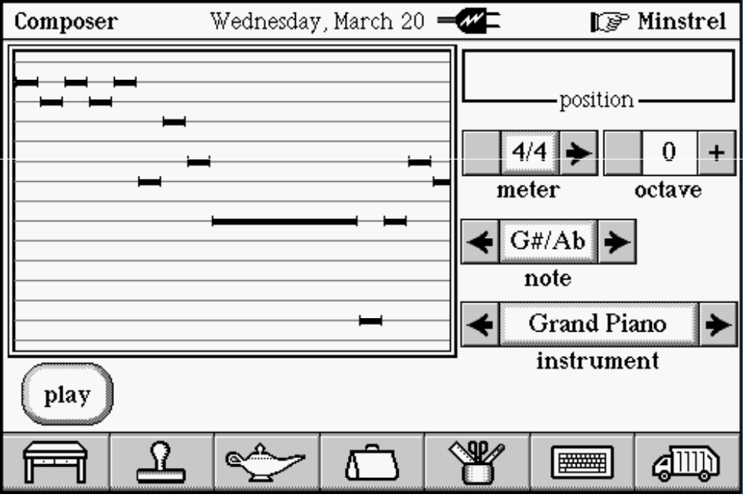
[** Figure 8 Ð The Composer Scene, FŸr Elise **]
YouÕll notice the odd design to the main note display. This is known as a Òpiano rollÓ view, since it duplicates the piano rolls used to drive old player pianos. For a single instrument, a standard staff is fine (although drawing a staff is a nightmare for a song of any complexity at all), but for many instruments, each with their own ranges and each with their own notation (G-clef for treble instruments, F-clef for bass instruments, both F and G clefs for piano, tablature notation for guitars and percussive notation for percussion), this notion is far too unwieldy.
The piano roll above shows the beginning of the melody line for BeethovenÕs ÔFŸr EliseÕ. The controls along the right side of the screen specify a one-note-at-a-time entry system.
The sad part of this story is that I havenÕt finished the composition tool yet; all it can do now is display songs recorded by the keyboard. MaybeÉ maybe next time. E-mail me if youÕd like to see it!
Coda
The MIDI synthesizer in Magic Cap is a little ÔextraÕ that didnÕt have to be there; itÕs unusual to find such a thing in a PDA! Along with the animation support, Magic Cap has the potential to put a little bit of multimedia all sorts of places, making the operating system a little nicer place to be. All thatÕs needed are the right tools to unlock that potential. Minstrel is not the most fully featured sequencer in the world, but it could be the base for a powerful composition tool. Combine this with a serial connection to a MIDI interface, and the music world could be your oyster.
This article would never have been possible without the help of Peter Drescher of Twittering Machines, who composed and sequenced the built-in Magic Cap songs and told me things about the Magic Cap synthesizer that IÕd never have discovered on my own; Zarko Draganic, who wrote the Magic Cap sound and music systems and gave me necessary nudges in the right direction when I was totally lost; Dean Yu of General Magic Technical Support, who responds so quickly to my whimpers for help that itÕs almost quicker to ask him than to look it up myself (kidding!); and Greg Satz, for creating the other great way of getting a MIDI file into the communicator, and the only way if you donÕt happen to have the development system.

